Terms of Reference
Handling Market Access Issues

Background
The seed sector is often exposed to several market access issues (incl. of phytosanitary origin), due to seeds being produced in countries other than where treatment, packing and sales take place.

Market access issues have always been part of ISF’s core business, but they are becoming increasingly common, due to several reasons some of them common in origin where others will be unique. Many projects to facilitate the international trade of seed have been completed by the ISF and several are ongoing. This work is carried out by horizontal committees and crop specific sections. However, ISF horizontal committees mainly deal with policy issues while market access issues often require detailed technical knowledge and immediate action.

A summary of the process can be found in APPENDIX 1 where a detailed explanation of the scope, criteria and roles and responsibility is explained below.

Scope
- Assessment of the reported issues
- Develop action plans that may offer solutions for existing problems and identify key stakeholders to engage and negotiate with.
- Carry out the agreed actions.
- Share best practice on handling market access issues with ISF members.
- The group will be activated only as and when an issue arises.
- Reported incidents of market access should be verified by the respective national seed association. The involvement of national associations is required during the entire process.
Criteria on how to assess market access issues (not an exhaustive list)
- It must have a broad implication to the seed industry
- It must cause high economic impact to more than one company
- If initially localised, it can spread to other countries and companies in a short period of time (e.g. disease outbreaks of Tobamoviruses)
- It must be an emerging issue
Role of the ISF Secretariat
ISF Secretariat is responsible for:
- Receipt of the completed Reporting Sheet via email – Seed Health Manager
- Initial assessment of the reported issue – Relevant person in the Secretariat
- Discussion and brainstorming – ISF Tec Hub team
- Drafting of the proposed plan – ISF Tec Hub team
- Consult with the relevant Committee, Sub Committee and/or Section Chairs – based on the type of issue - via email
- Consult with the Executive Committee on the proposed plan - via email
- Agreement on the experts who will be part of the task group - Secretariat and the relevant Committee, Sub Committee and/or Chairs
- Definition of the scope of the work and an agreed timetable

Roles and responsibilities of ISF members
Reporting issues
- For every reported issue the ISF Reporting Sheet is required to be completed (see below).
- ISF members are encouraged to report market access issues as soon as they became aware of to the ISF Secretariat. The ISF Secretariat verifies whether the reported issue fulfils the conditions highlighted in the ISF Reporting Sheet.
Cooperation
- ISF members are required to work together with the Secretariat on tasks related to the reported issue.
Transparency
- ISF members are required to disclose all information related to the reported issue including any actions already taken.
- ISF will make all reported issues available to members, including actions taken.

APPENDIX 1 – Process flow

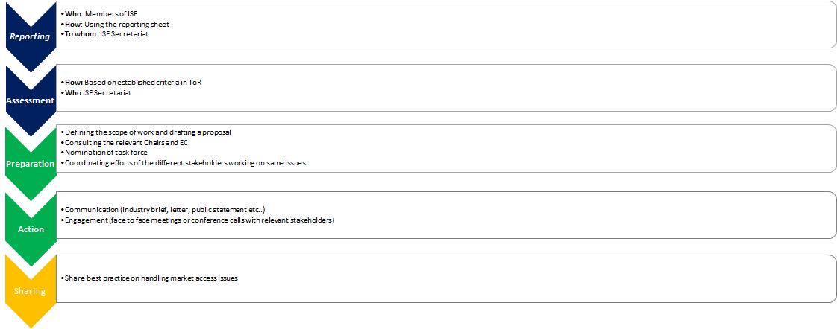

Reporting Sheet
Handling seed market access issues
Send the complete form by email to r.souzarichards@worldseed.org with the subject line: Market Access issue

1. | Reporting Member(s):
2. | Country or region where the issue happened:
3. | Type of issues:  Phytosanitary (e.g. emergency measures, disease outbreaks)  WTO SPS Notification  Seed legislation (seed sampling, testing, certification, variety registration, etc.)  Intellectual Property (e.g. PVP application)  Other
4. | Products impacted(species):
5. | Estimated volume/value of seed trade impacted per year:
6. | Regions or countries that are impacted:
7. | Short description of the problem:
8. | Date of entry into force (dd/mm/yy)/period of application (as applicable):
9. | Are the transcripts of relevant regulations publicly available?  If yes, please copy the link of the respective websites or send the documents (preferably in English)
10. | Ministry, agency or authority designated to handle comments:
11. | Summary of any action that has already be taken by your company as well as by other stakeholders (NSAs/RSAs/or other industry organization):

Disclaimer: The information shared by companies will be handled in a confidential way by the responsible person at the ISF Secretariat. If the information needs to be shared with a relevant body of ISF, the publication will be made anonymously and no business sensitive information will be disclosed.

